## Assessing gene essentiality

We performed *in silico* single gene knockout analysis using COBRApy to evaluate the impact of each gene in every media condition. We assessed the effect of these knockouts by deleting every gene in the model and performing Flux Balance Analysis (FBA) for each media condition. The lethal genes for *C. clementina* were identified from the FBA simulations that resulted in zero flux through the biomass and hence limited growth of the model. In the CTRL media, the eight deleted genes, namely, photosystem I subunit O (CICLE_v10029515mg), photosystem I reaction center subunit N (CICLE_v10002687mg), protein curvature thylakoid 1B (CICLE_v10022571mg), photosystem I reaction center subunit III (CICLE_v10016540mg), photosystem I reaction center subunit V (CICLE_v10009769mg), and photosystem I reaction center subunit psaK (CICLE_v10017170mg), photosystem I P700 apoprotein A1 (CICLE_v10030467mg), photosystem I psaA/psaB protein (CICLE_v10004112mg) belong to the PSI component. As the control media contains only nitrate, minerals, but no organic carbon source, removal of these proteins necessary for photosynthesis results in no growth. Three genes, thiamine biosynthetic bifunctional enzyme TH1 (CICLE_v10000782mg), phosphoribosylglycinamide formyltransferase (CICLE_v10016118mg), and phosphoribosylaminoimidazole-succinocarboxamide synthase (CICLE_v10001304mg), were observed to be essential in the control, as well as in SUCNO3 and SUCTHR. While CICLE_v10000782mg is part of vitamin metabolism, CICLE_v10016118mg and CICLE_v10001304mg belong to purine metabolism.

Furthermore eight *C. clementina* genes, 4-hydroxy-tetrahydrodipicolinate reductase 1 (CICLE_v10020914mg), dihydroxy-acid dehydratase (CICLE_v10004565mg), UDP-N-acetylglucosamine diphosphorylase 1 (CICLE_v100149971mg), 2-isopropylmalate synthase 1 (CICLE_v10020218mg), imidazoleglycerol-phosphate dehydratase (CICLE_v10005599mg), histidinol dehydrogenase (CICLE_v10015058mg), aspartokinase 2 (CICLE_v10014778mg), and 4-hydroxy-tetrahydrodipicolinate synthase (CICLE_v10001621mg), linked to amino acid metabolism were also identified as lethal genes for growth in CTRL, MS, SUCNO3, and SUCTHR. Given that these growth media do not contain any amino acids, the plant requires these genes to synthesize amino acids for growth and maintenance.

We identified another set of 44 genes (Supplementary File 5) that were essential for all the growth conditions. These genes are part of different metabolic pathways like carbohydrate metabolism (2), amino acid metabolism (8), nucleotide metabolism (4), lipid metabolism (12), transporters (2), cofactor and vitamin metabolism (7), energy metabolism (3), and metabolism of terpenoids (4). Out of the 44, two genes caffeate methyltransferase (CICLE_v10020814mg), and short-chain dehydrogenase reductase 3b (CICLE_v10021745mg) were linked to flavonoid metabolism seem to play a significant role in growth of the model.

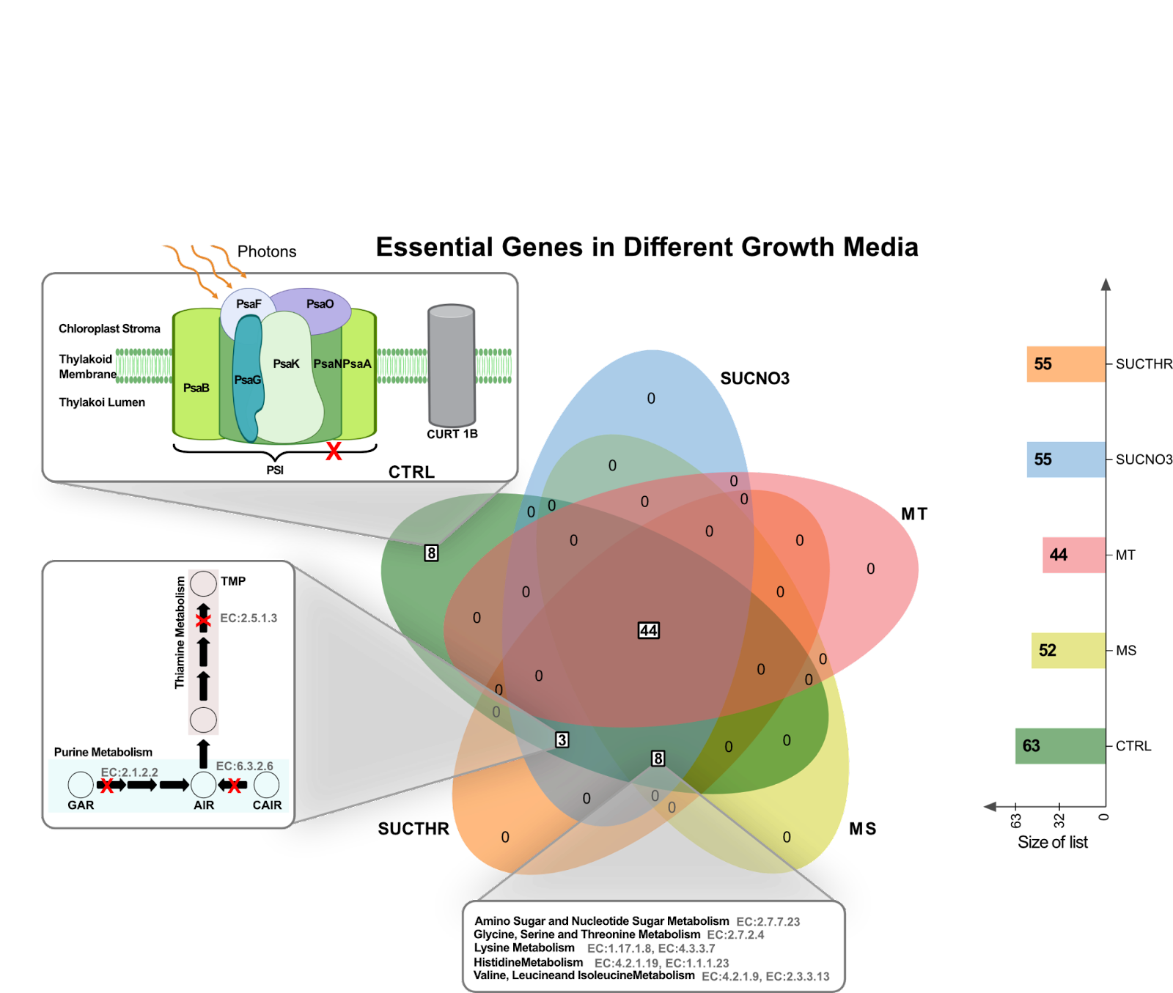

**Fig 3. Essential metabolic genes in different growth media.** Only the CTRL medium contained a set of eight unique lethal genes, not shared under other conditions. These genes were associated with the photosystems. Three genes related to purine and pyrimidine metabolism were found essential for growth CTRL, SUCNO3, and SUCTHR. Another eight genes for amino acid metabolism were found essential for growth in CTRL, SUCNO3, SUCTHR, and MS, which do not provide external amino acids. A total of 44 geneswere identified as lethal for the five growth media conditions.